Large Combustion Plant reporting under Directive 2010/75/EU

Manual of Reporters

Version 1.0

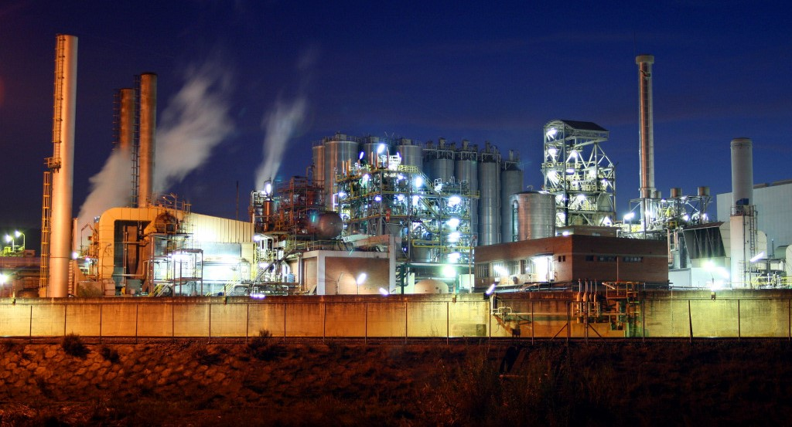Cover design: EEA

Cover photo: Jorge Franganillo, Creative Commons Attribution 2.0 Generic (<https://goo.gl/rqHYk6>)

Layout: EEA

# About this Manual of Reporters

This Manual of Reporters aims to clarify the reporting workflow and tool. It has been developed by EEA. The current EEA project manager for this data flow is Marthe Granger. Please refer to her for further enquiries ([marthe.granger@eea.europa.eu](mailto:marthe.granger@eea.europa.eu)).

# Version control

|  |  |  |
| --- | --- | --- |
| **Version ID** | **Date** | **Description** |
| 1.0 | December 2017 | Official version for reporting |

# Table of contents

About this Manual of Reporters 2

Version control 2

Table of contents 3

1 Reporting obligation 4

2 Access to the tool 4

3 General workflow 4

4 Reporting steps: a detailed explanation 5

5 Automated quality assurance 20

6 Quality assurance after submission 21

7 Resubmission of data reported under the LCP Directive 21

# Reporting obligation

These guidelines explain how to use the electronic infrastructure for reporting information to the European Environment Agency (EEA) and the European Commission in relation to Large Combustion Plants under Chapter III of Directive 2010/75/EU on Industrial Emissions (IED). The reporting obligation is provided by Article 72 of IED and also includes additional obligations on certain derogatory regimes mandated by other articles of the Directive.

Details on the reporting obligation are provided in the Reporting Obligation Database at <http://rod.eionet.europa.eu/obligations/756>[1]

# Access to the tool

Reporting to this inventory on LCPs requires:

* An **Eionet account** with user name and password is required as well as permission to upload the national delivery.
* Having specific **permissions to report**, on behalf of your country, to the relevant obligation. The reporting on LCPs under the IED is recorded at the Reporting Obligation Database as obligation 756 (<http://rod.eionet.europa.eu/obligations/756>)

Permissions for this dataflow are managed in a so-called Extranet list. The list of representatives that currently have permissions to report for a given country can be seen online at <http://www.eionet.europa.eu/ldap-roles/?role_id=extranet-lcp-reporter>

Please contact the EEA data flow manager ([marthe.granger@eea.europa.eu](mailto:marthe.granger@eea.europa.eu)) in case the list appears to be outdated for your country. She will handle anything necessary for the right representative of your country to get access to the tool.

# General workflow

All deliveries are provided via the Reportnet Central Data Repository (CDR), which is maintained by the European Environment Agency (EEA). The workflow has the following 10 steps:

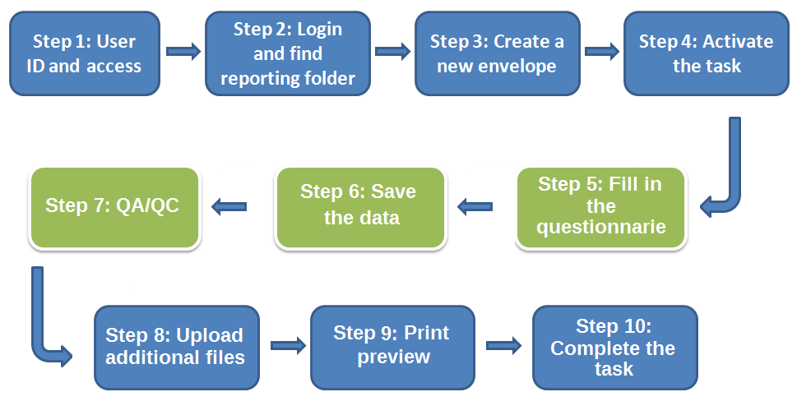

# Reporting steps: a detailed explanation

* **Step 1: User accounts and access permissions**

In order to report, an Eionet account with user name and password is required as well as permission to upload the national delivery. Please inform the EEA data flow manager ([marthe.granger@eea.europa.eu](mailto:marthe.granger@eea.europa.eu)) about who will be the person(s) responsible for the reporting, so that the necessary arrangements can be made.

* **Step 2: Login to the Central Data Repository and open your folder**

You can access EEA’s Central Data Repository (CDR) at <http://cdr.eionet.europa.eu>

When preparing for the delivery of the LCP questionnaire, you first have to log in by using your Eionet user name and password and then navigate to the respective folder of you country (see the links below).

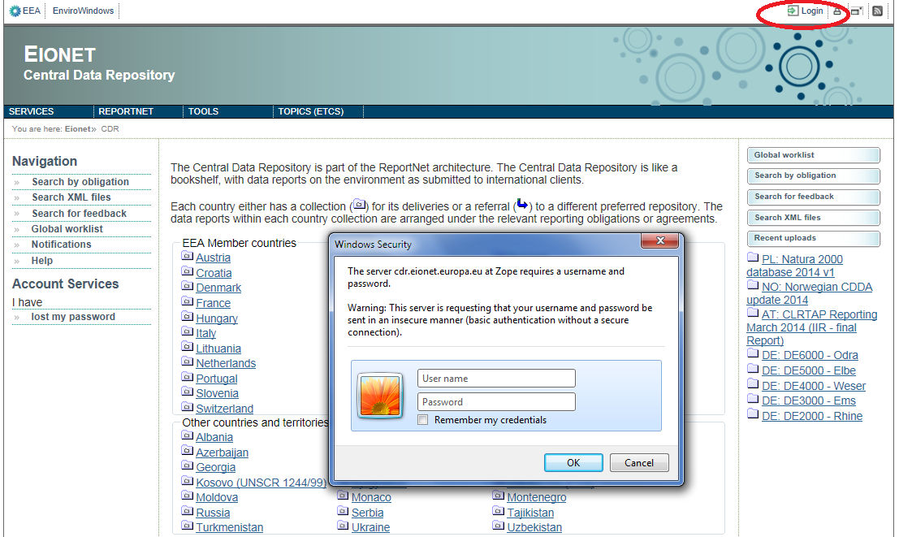

Country URL to "LCP - article 72 IED (Large Combustion Plant – Industrial Emission Directive article 72)" reporting folder

|  |  |  |
| --- | --- | --- |
| **Country** | | **LCP - article 72 IED reporting deliveries to CDR** |
| **Name** | **ISO** | **Hyperlink to national folder** |
| Austria  Belgium  Bulgaria  Croatia  Cyprus  Czech Republic  Denmark  Estonia  Finland  France  Germany  Greece  Hungary  Iceland  Ireland  Italy  Kosovo (UNSCR 1244/99)  Latvia  Liechtenstein  Lithuania  Luxembourg  Malta  Netherlands  Norway  Poland  Portugal  Romania  Slovakia  Slovenia  Spain  Sweden  Switzerland  Turkey  United Kingdom | AT  BE  BG  HR  CY  CZ  DK  EE  FI  FR  DE  GR  HU  IS  IE  IT  XK  LV  LI  LT  LU  MT  NL  NO  PL  PT  RO  SK  SI  ES  SE  CH  TR  UK | <http://cdr.eionet.europa.eu/at/eu/lcp_ied/>  <http://cdr.eionet.europa.eu/be/eu/lcp_ied/>  <http://cdr.eionet.europa.eu/bg/eu/lcp_ied/>  <http://cdr.eionet.europa.eu/hr/eu/lcp_ied/>  <http://cdr.eionet.europa.eu/cy/eu/lcp_ied/>  <http://cdr.eionet.europa.eu/cz/eu/lcp_ied/>  <http://cdr.eionet.europa.eu/dk/eu/lcp_ied/>  <http://cdr.eionet.europa.eu/ee/eu/lcp_ied/>  <http://cdr.eionet.europa.eu/fi/eu/lcp_ied/>  <http://cdr.eionet.europa.eu/fr/eu/lcp_ied/>  <http://cdr.eionet.europa.eu/de/eu/lcp_ied/>  <http://cdr.eionet.europa.eu/gr/eu/lcp_ied/>  <http://cdr.eionet.europa.eu/hu/eu/lcp_ied/>  <http://cdr.eionet.europa.eu/is/eu/lcp_ied/>  <http://cdr.eionet.europa.eu/ie/eu/lcp_ied/>  <http://cdr.eionet.europa.eu/it/eu/lcp_ied/>  <http://cdr.eionet.europa.eu/xk/eu/lcp_ied/>  <http://cdr.eionet.europa.eu/lv/eu/lcp_ied/>  <http://cdr.eionet.europa.eu/li/eu/lcp_ied/>  <http://cdr.eionet.europa.eu/lt/eu/lcp_ied/>  <http://cdr.eionet.europa.eu/lu/eu/lcp_ied/>  <http://cdr.eionet.europa.eu/mt/eu/lcp_ied/>  <http://cdr.eionet.europa.eu/nl/eu/lcp_ied/>  <http://cdr.eionet.europa.eu/no/eu/lcp_ied/>  <http://cdr.eionet.europa.eu/pl/eu/lcp_ied/>  <http://cdr.eionet.europa.eu/pt/eu/lcp_ied/>  <http://cdr.eionet.europa.eu/ro/eu/lcp_ied/>  <http://cdr.eionet.europa.eu/sk/eu/lcp_ied/>  <http://cdr.eionet.europa.eu/si/eu/lcp_ied/>  <http://cdr.eionet.europa.eu/es/eu/lcp_ied/>  <http://cdr.eionet.europa.eu/se/eu/lcp_ied/>  <http://cdr.eionet.europa.eu/ch/eu/lcp_ied/>  <http://cdr.eionet.europa.eu/tr/eu/lcp_ied/>  <http://cdr.eionet.europa.eu/gb/eu/lcp_ied/> |

* **Step 3: Create a new envelope**

Now **create a new envelope** which will contain your data delivery by clicking on the button ‘New envelope’ at the upper right corner of the screen:

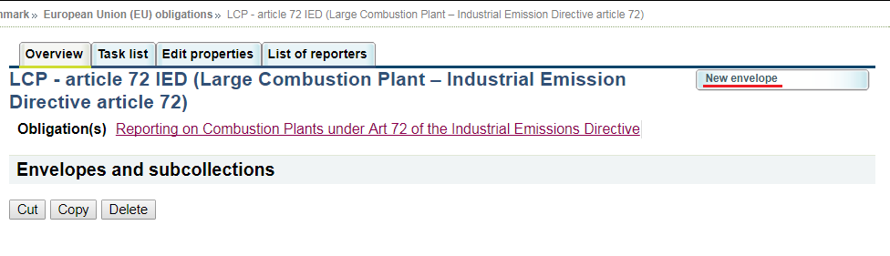

# Provide meaningful details about your delivery on the “Add Envelope” page. At least “Title” and “Relating to which year” fields have to be filled in.

# The Envelope title should briefly summarise the delivery by providing the information about the reporting country, obligation and year. Then it will be easier for the reporter and other stakeholders to find the delivery. “Relating to which year” indicates the period the report will cover.

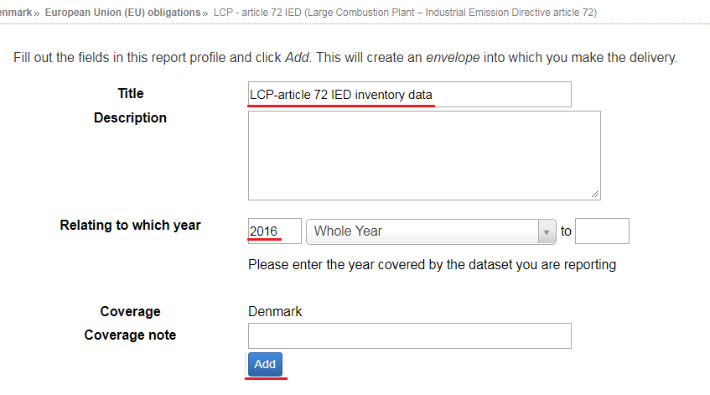

After clicking "Add" button the envelope is created and listed in the LCP reporting folder.

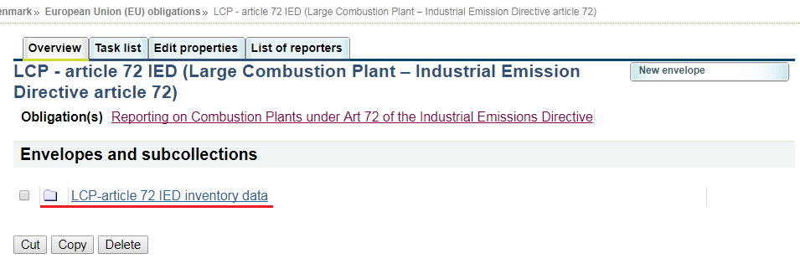

* **Step 4: Activate the task**

The way to start the work in the envelope is to enter the envelope by clicking on the envelope name and activate the **Draft** task by clicking on the <*Activate task: Draft*> link or by pressing the <*Activate task*> button.

Activating means that you have reserved the envelope for yourself to work on. Other users will not be able to modify it until the envelope is deactivated or released. Your new envelope is now in Draft status and files can be added.

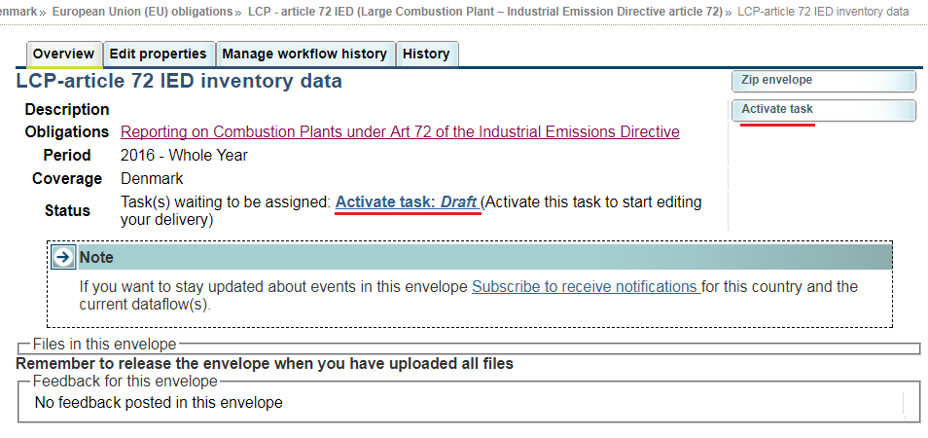

* **Step 5 Start to fill out the online questionnaire**

The next step is to fill in your report by using the online questionnaire, which can be achieved by clicking on the link on top of the envelope:

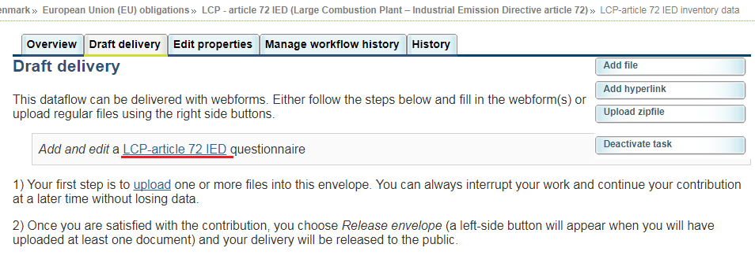

**Data Preloading**

The first time you open the web-form it will take some time to pre-load the plants from the previous report, in aid of the reporting process. All the plants of the previous reporting round will be fetched, with their previous name, and if available their location data from the E-PRTR database. A message will appear informing you for this operation.

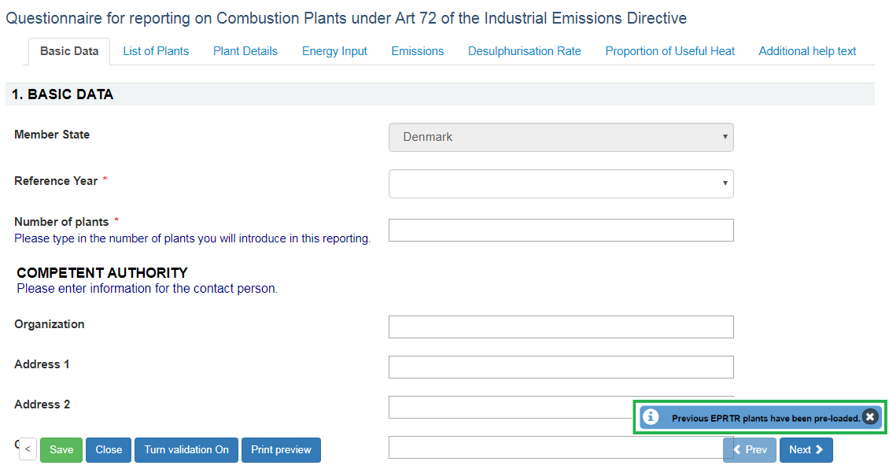

**N.B.**

The automatic linking might not cover all the required information. Please double check the data and add or fix the values, if necessary. In case of a plant that was pre-loaded, has some of its attributes this year changed (e.g. different Plant Name), you should not delete the pre-loaded plant and add a new one, because it will be assigned a new Plant ID. You will have to edit the plant attributes, as explained in the following sections.

**General principles about the use of the online questionnaire**

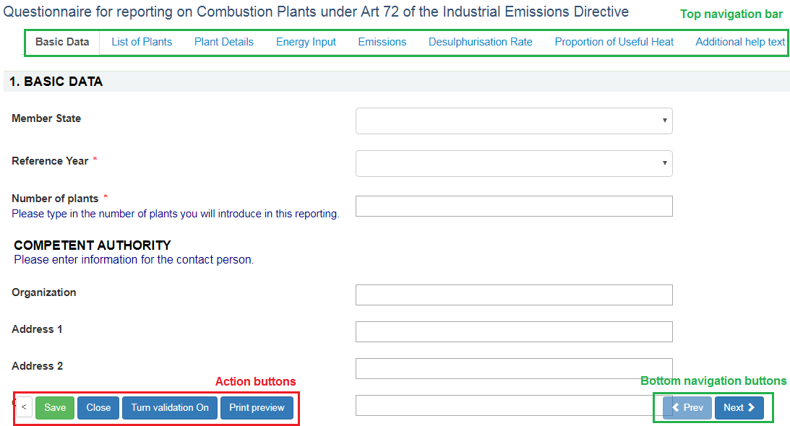

The questionnaire is divided into 7 reporting forms and the form with additional help texts.

**Navigation**

* All the forms are accessible from the **top navigation bar** (tabs) below the questionnaire title. The active form tab is displayed in bold font.
* The **bottom navigation buttons** under the reporting form contains links to the **next** and **previous** forms. After filling in one form you don’t have to scroll on top of the page, but you can continue by clicking on the **Next** button.
* The **bottom navigation bar** with **action buttons** can be turned invisible by clicking on the left most grey “<” button. This feature is useful in case you have a small screen and you want to make more space for questions. The bottom navigation bar and action buttons can be restored by clicking green “>” button in the same location.

**Reporting forms**

* **Basic data** – Basic data about the report and national contact person. Member state field is filled in automatically. It is required to select the reference year and fill in the number of plants, as well as at least an email for further communication if need be (between reporter and EEA).
* **List of plants** – on this form it is possible to add new plants, insert basic information about the plants and plants' location. The automatic linking between LCP plants and E-PRTR installations data has been established. The linked data has been pre-loaded automatically when opening the form for the first time. The automatic linking might not cover all the required information. Please double check the data and add or fix the values, if necessary. On this form it is also possible to delete plants from the list.
* **Plant Details** – on this form detailed data about the plants can be entered.
* **Energy Input** – on this form data for energy input can be entered.
* **Emissions** – on this form data for total emissions to air can be entered.
* **Desulphurisation rate**  – on this form data for the sulphur content of the indigenous solid fuel and rate of desulphurisation achieved can be entered.
* **Proportion of Useful Heat** - on this form data for the proportion of useful heat that is produced in the plant for a given year can be entered.
* **Additional help text** - on this form additional guidance of how to fill in reporting forms can be found.

**Action buttons**

* **Save** – saves the data in the CDR envelope in an XML file. All input fields are validated before saving the file. The form will notify you when you try to save invalid data.
* **Turn validation On/Off –** you can turn the validation on and off at any time to see if inserted data follow the rules.
* **Close** – closes the online questionnaire and goes back to CDR envelope, after prompting you to save if necessary.
* **Print preview**–opens the questionnaire in printable format in a new window. **NB** You need to disable the pop-up blocker for this site if it is turned on.

**View mode of the reporting forms**

All the reporting forms are opened in view mode by default. The data is not editable in view mode. The view mode of the forms simplifies the browsing of the data by providing the following functionality:

* The visible rows of the table are limited to 50 rows and it is possible to browse through the pages if there are more than 50 entries. Use paging buttons on top of the table to navigate between the pages.
* The table entries can be filtered by the plant name when inserting the search string into the search box on upper right corner of the table
* The table rows can be sorted when clicking on column header. The tables are sorted by plant name by default.
* The view mode of the table displays validation errors next to the reported value, when validation is turned on.

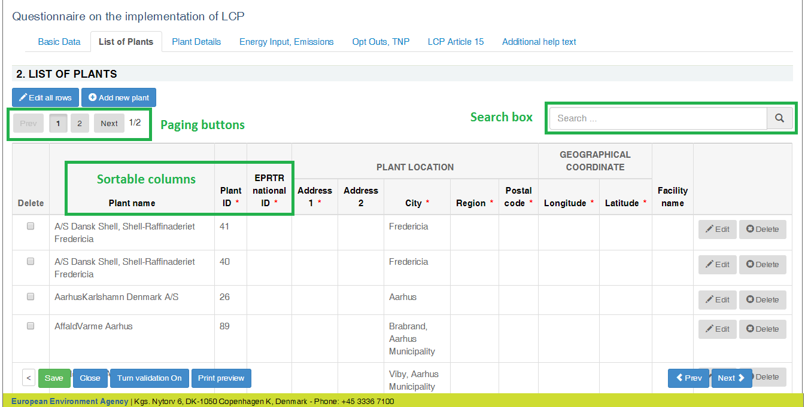

**Edit mode of the reporting forms**

All the tabular reporting forms can be switched to edit mode by clicking on  button.

The edit mode allows you to edit the table like an Excel spreadsheet and contains basic validation functionality e.g. the background of cells containing text in numeric fields turns red.

The rows can be sorted by clicking on the column header.

From the “List of plants” form it is possible to add a new row (plant). You may add one new row at a time, and a new “Plant Id” is automatically generated after clicking “Edits done”.

On the rest of the forms, the fields Plant Name and Plant Id are not editable.

The navigation to other forms is disabled when switching to edit mode. Click on  button to finish editing and go back to view mode.

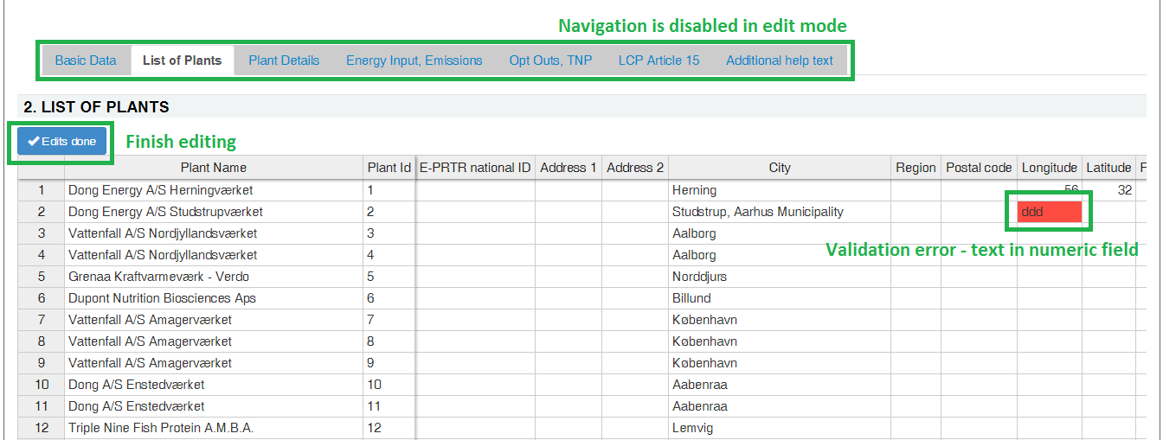

**Copy and paste data from Excel**

The edit mode of the form behaves similarly as MS Excel spreadsheet. It is possible to select an area (multiple rows and columns), and copy and paste it to other forms. It is also possible to select multiple cells in Excel spreadsheet and copy the data to reporting form, but there are certain limitations when doing this:

* decimal values have to use points instead of commas
* columns containing checkboxes accept only "true" or "false" (in lower case) values. “True”, “TRUE”, “Y”, “1” won’t work. Instead they will generate “#bad value#”.
* you cannot copy and paste values into read-only fields:
  + PlantName on all forms except "List of Plants"
  + PlantID, which is read-only on all forms
  + fields that are read-only by default, but will be editable after ticking the checkbox value – for example on "Plant Details", while “Boiler” is not ticked, it is not possible to paste information into the field “MWth – boiler”

**NB!** Before pasting data from Excel, you should make sure that the plants on the Excel spreadsheet and the webform are in the same order, e.g. by alphabetical sort.  
**NB!** The fields that are editable after ticking a checkbox, will remain empty and have to be filed manually.  
**NB!** Please verify the copy-pasted data by comparing the source values in Excel and paste results on  
webform, to be sure that the data and formatting was transferred correctly. Fix differences if needed.

**Add new plants one by one**

It is possible to add new plants one by one only on "List of Plants" form by clicking on  button on top of the table. It is required to fill in all mandatory fields to be able to successfully add a plant.

If "EPRTR national ID" value is entered, then it is possible to automatically load the installation data from E-PRTR database and link it to plant data by clicking on  button. The confirmation to fill in data automatically is asked, if the data is found for given EPRTR national ID.

**NB!** **You should be adding only plants that were not reported in the previous round, since if they were, they will have been pre-loaded. Before adding a new plant please check the available plants, by using the search box.**

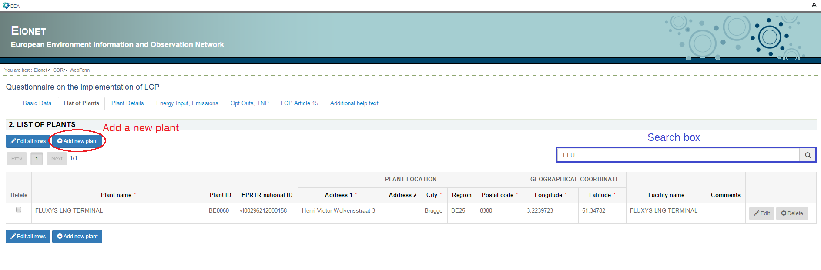

**Edit rows one by one**

Besides modifying the table rows in edit mode, it is also possible to edit rows one by one when clicking "Edit" button at the end of the row. The functionality is especially useful when the form displays validation errors in read only mode.

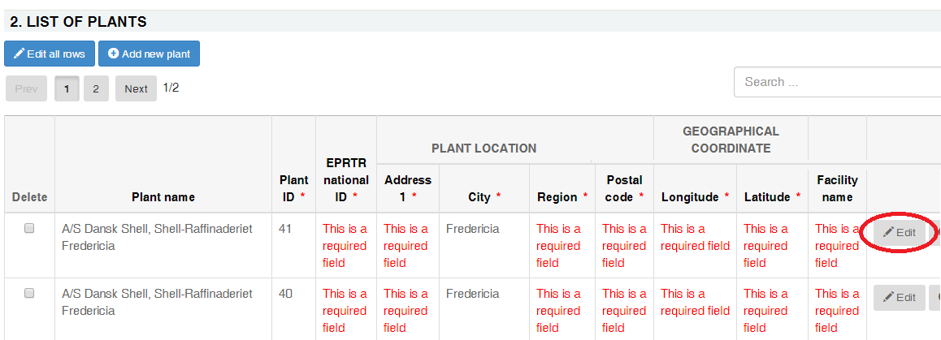

After clicking on "Edit" button a modal dialogue will be open with the data from selected row.

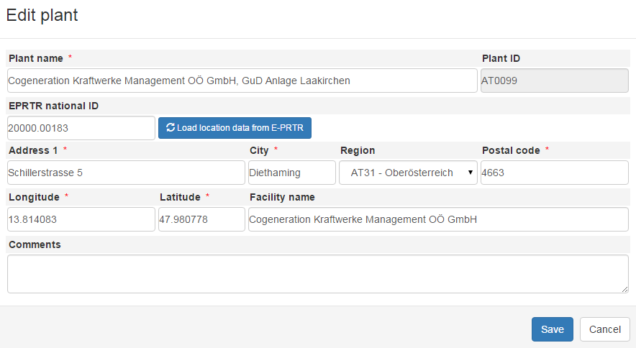

**Delete plants**

It is possible to delete plant rows only on "List of Plants" form. The deletion can be done one by one by using "Delete" buttons in right most column. The multiple plant rows can be deleted by using checkboxes in the left most column and clicking red "Delete selected" button under the table.

The deletion of a plant is permanent and should be performed with caution. Re-adding a plant that was deleted will result in a mismatch of the auto-generated Plant ID. On the case that a plant had an attribute changed from the previous report, you should edit the plant as explained above.

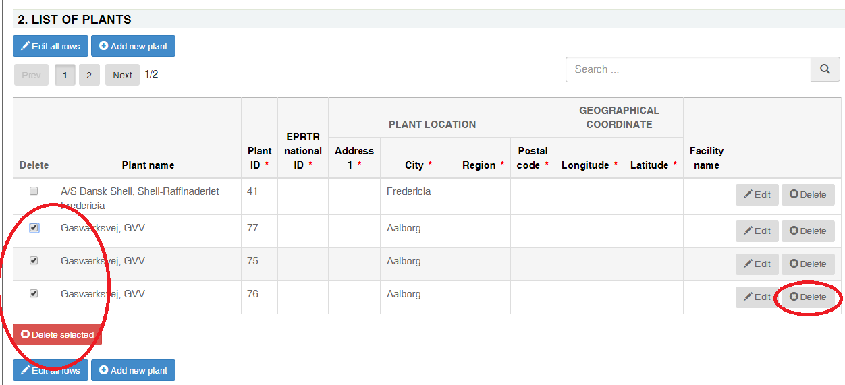

* **Step 6 Save data**

**NB! The online questionnaire does NOT save your changes automatically**

Save operation runs after clicking the 'Save' button on the main window. It also runs every time you click the 'Save' button in some modal view. It does not run automatically after editing with ‘Edit all rows’ button. A notification will appear after a save operation, informing you about the current state of the questionnaire. There are 3 types of messages.

1. If the questionnaire is incomplete, meaning that there are mandatory fields that have been not been filled yet, then the following message appears. The mandatory fields are denoted with an asterisk. You may turn the validation on, and the missing values will be flagged with red messages.

You don’t have to fill in all data at once, this is for your information.

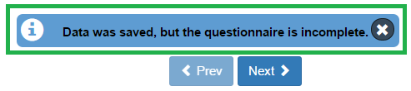

1. If all the mandatory fields have been filled, then some basic Quality Assurance/ Quality Control (QA/QC) rules will run after the save operation

1.1 Basic data completeness

1.2 Number of plants

2.1 Unequivocal naming of plants

3.2 Rated thermal input value

3.4 Plausibility of capacity added

3.5 Plausible reporting of substantial change

3.6 Date of start of operation and legal status

If one or more from the above QA/QCs fail then the message “Data was saved but the questionnaire did not pass some QAs” appears after the save operation :

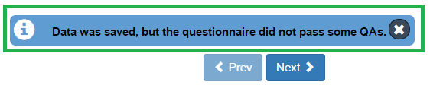

1. If all of the above QA/QCs pass then green message “Data is saved successfully” appears :  
     
   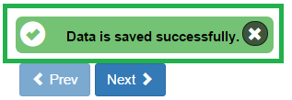

These QA/QCs are preliminary, and the main QA/QC functionality is explained in **step 7.**

**N.B.** **You don’t have to fill in all data at once. You can go back and modify the online questionnaire for completions or amendments later at any time in CDR:**

either by clicking on the “Modify the LCP-article 72 IED questionnaire" link on envelope page or by clicking on the corresponding XML file name in the list of files and then clicking on the “Edit with Web form” link on document details page

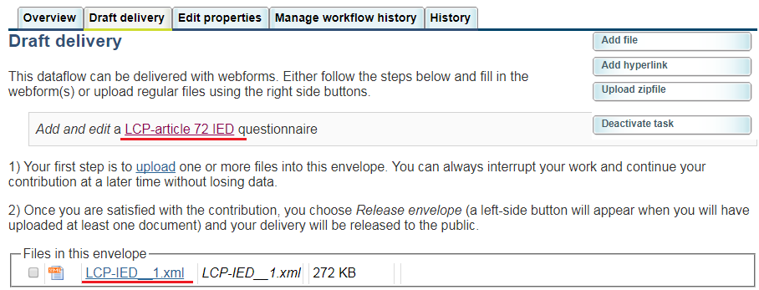

* **Step 7: QA/QC**

Section 8 provides details on what aspects are checked from the thematic point of view while here we merely explain the workflow.

**The first step** of the QA/QC process is running the QA #1. The “Run QA #1” button initiates a technical validation of the file according to the xml schema. You should begin this process if the last message on the Save operation was the green “Data is saved successfully”.

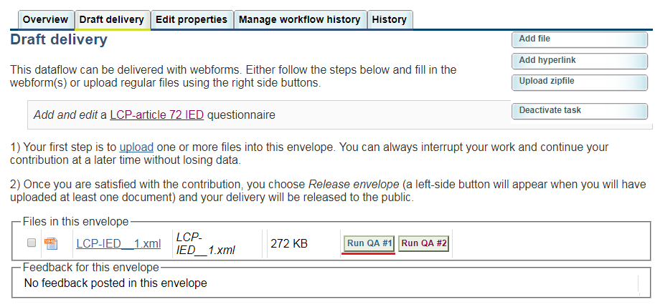

The result should be looking like this :

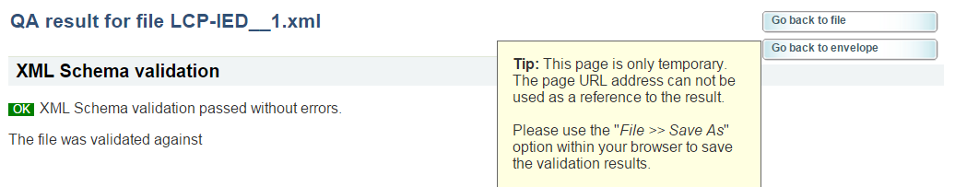

**Then** you should run the QA #2, which initiates a quality check on the reported data (after click on Go back to envelope / Go back to file).

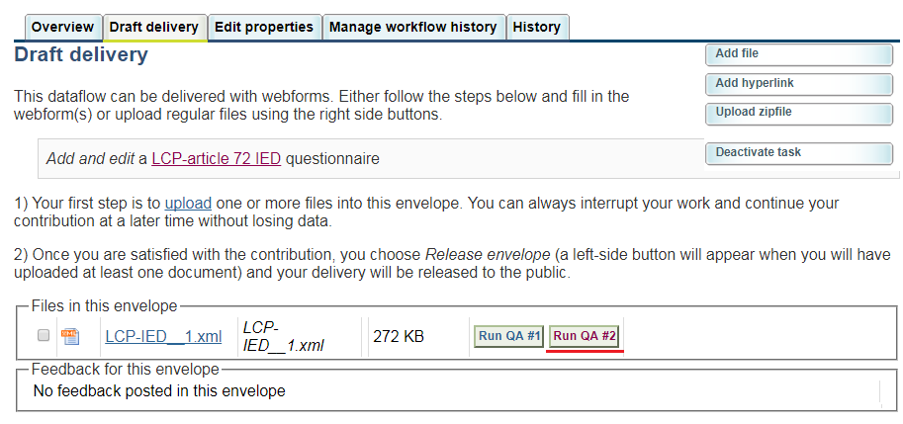

After allowing the QA/QC script a few moment to run, it presents the results in a new page.

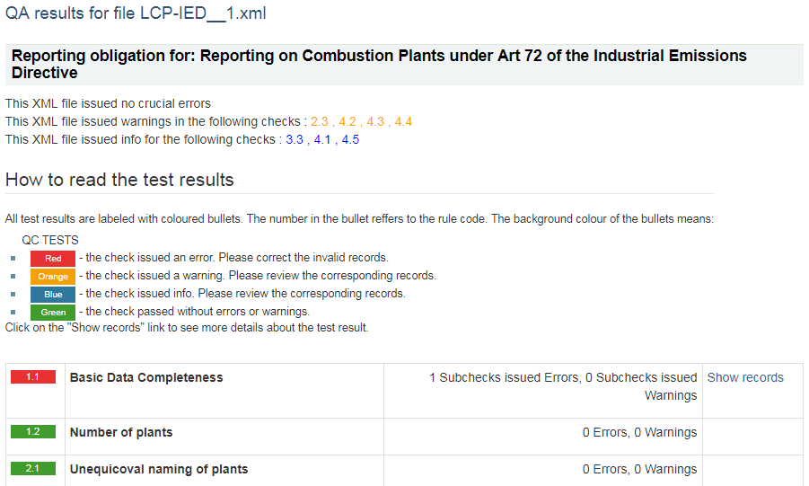

On the top are the concentrating results of the QA, displaying if any checks issued errors. If there are checks with errors, after reviewing the corresponding records you should edit the data through the web form and re-do this step.  
Warnings and info may issued by checks for some records that should be reviewed for their integrity, in order to improve data quality.

There is a table of all the checks that ran with a colour coded bullet that shows the status of the check, the check’s name and the results. If there are errors, warnings or info for a check, there is a ‘Show records’ button, which will present the related fields along with an explanation.

* **Step 8: Upload additional files**

You can upload and submit additional files in the envelope.

You can restrict the uploaded file from public view by ticking the box “*Restricted from public view*”.

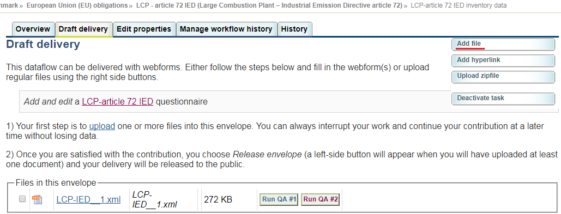

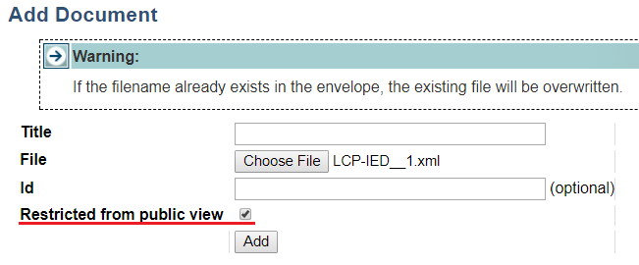

* **Step 9: Download or print out the report (optional)**

You can download or print out the report in CDR. This functionality is available on document details page. Click on the XML file name on CDR envelope to open the **Document details** page. All available formats are available at the top of the page in “View file as“ area.

Click on the “**HTML preview**” link to download in HTML format or print the report.

Click on the “**Excel preview**” link to download in report in Excel format.

Click on the “**Original**“ link to open the raw XML file in your browser.

The Document details page contains also a link to the online questionnaire. Just click on the link “*Edit file with Web form*” if you have found something to change or amend in the answers and you are able to edit all the answers.

"**Run QA #..**" button is available both on envelope page and document details page.

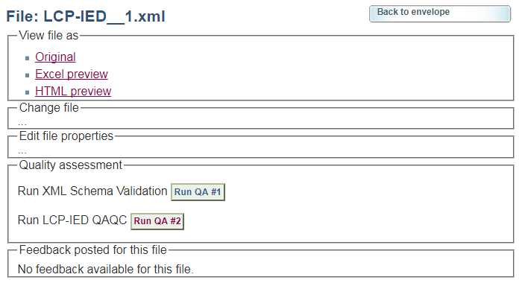

* **Step 10: Complete task**

When you **finish the drafting of your work**, you need to click on the right side button “**Release envelope**”.

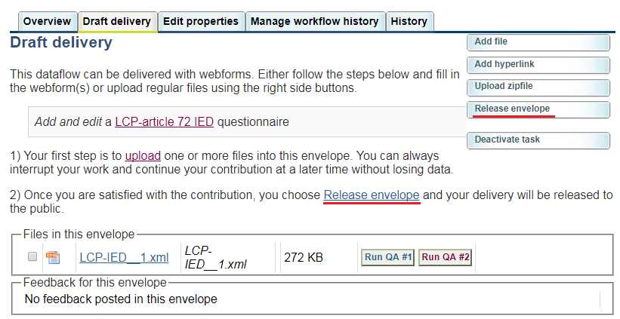

Now the report is submitted and received by the EU and the envelope is available to the public (if you did not tick the box “Restricted from public view”. After a few minutes, confirmation of receipt message and automatic feedback is stored automatically in the envelope's feedback area. Additional feedback might be provided by the Commission or EEA.

You may review the confirmation of receipt by clicking the corresponding link on the envelope.

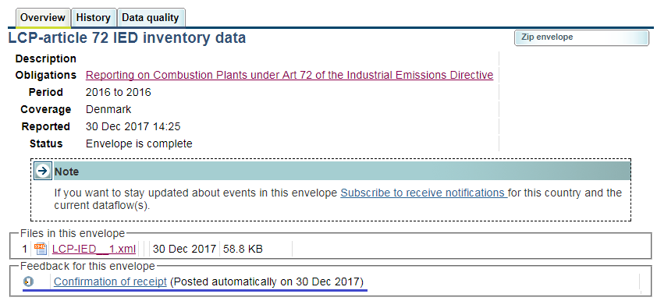

# Automated quality assurance

|  |  |
| --- | --- |
| **Basic Data Completeness** | The data inserted in the sheet ‘Basic data’ is complete and allows for a unique identification of the reporter for further contact if need be. |
| **Number of plants** | Number of plants reported is identical to the number of plants declared in the Basic Data tab. |
| **Unequicoval naming of plants** | Each plant needs to have a unique name. The tool flags up cases where it is not the case. |
| **Consistency of plant ID and name over time** | Plant ID and name need to be consistent over time for plants reported in previous years. |
| **Location check** | Geographical coordinates are located within the reporting country and are provided with the required accuracy. |
| **E-PRTR ID** | For each LCP, the corresponding E-PRTR ID is provided, where it exists (very few LCPs are not reported to the E-PRTR when releasing emissions below the threholds set in the E-PRTR Regulation). |
| **Rated thermal input value** | Rated thermal input > 7,000 MWth or < 50 MWth is flagged and confirmation is requested. Outside these ranges, the figures are not realistic and are likely a misuse of units. |
| **Plausibility of fuel input** | Flag cases where total fuel input is larger than rated thermal input (using the relationship between capacity and maximum TJ that are feasible to burn). |
| **Share in overall reported emissions** | The sum total LCPs emissions by pollutant is given as a percentage of national totals (reported under CLRTAP) for Energy, industrial combustion and refineries (NFR category 1A). LCP emissions must be below the figure provided to CLRTAP by definition. |
| **SO2 emission outlier test** | SO2 emissions are estimated from fuel input, using average emission factors, and compared to actual reported emissions. |
| **NOx emission outlier test** | NOx emissions are estimated from fuel input, using average emission factors, and compared to actual reported emissions. |
| **Dust emission outlier test** | Dust emissions are estimated from fuel input, using average emission factors, and compared to actual reported emissions. |
| **Consistency with emission trend at national level** | Emissions reported at national level for the reference year are similar to the average of the three previous years. |

# Quality assurance after submission

When the country submission is completed (step 10 as described in Section 7), the EEA peoceeds with a series of manual check on the data. These checks are compiled in a “feedback file”.

The feedback files include a worksheet with “step 1” checks (largely based on the checks in CDR) and a worksheet with “step 2” checks (comparison to E-PRTR data).

The EEA will notify countries on their submission’s quality and attach the relevant ‘feedback file‘. Countries will be given 15 working days to react.

Countries are usually asked to either:

* 1. Confirm correctness of the data by clarifying the issues raised in the feedback file. This confirmation is recorded in the feedback file asn sent back by email.

OR

* 1. If errors are confirmed, countries must resubmit the data and provide clarifications. The clarifications are also recorded in the feedback file, sent back by email.

The EEA documents these interactions with countres in the final publication of the LCP database.

# Resubmission of data reported under the LCP Directive

The EEA has discontinued the reporting tool under the previous obligation under LCPD. If countries are to make corrections of the data reported under that pre-exiting obligation, such reports have to be transmitted independently, contacting EEA ([marthe.granger@eea.europa.eu](mailto:marthe.granger@eea.europa.eu)) in order to implement the updates.

A specific mechanism will be enabled bilaterally to ensure the easiest and less burdensome procedure for these corrections.

1. Please note that this reporting will be integrated in E-PRTR as from 2019. Details on the matter are available in [this website](http://cdrtest.eionet.europa.eu/help/eprtr_lcp).